From http://www.atlasobscura.com/articles/eclipse-1878-weather-abbe-colorado-pikes

The Eclipse of 1878 Almost Killed the Father of the National Weather Service

Eclipse madness is real.
by Eric Grundhauser
August 04, 2017

Eclipse Madness

1,294
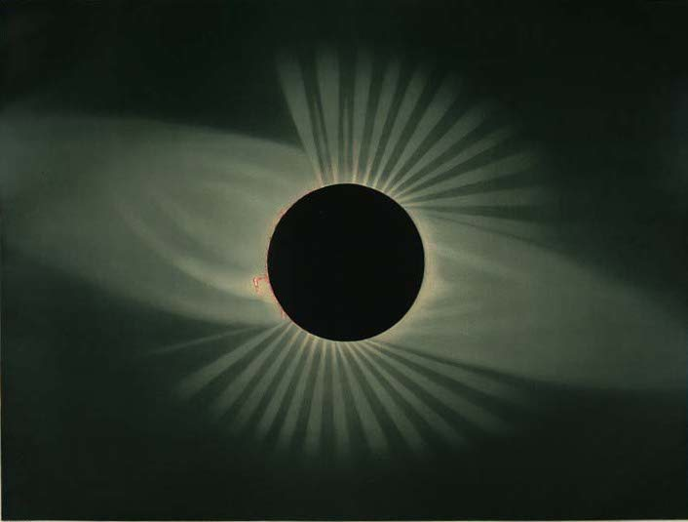The eclipse of 1878 as observed from Wyoming. Étienne Léopold Trouvelot/Public Domain
Millions of North Americans are expected to (carefully!) turn their eyes to the sky on August 21 to witness a total eclipse of the sun that will cross the U.S. from shore to shore. Eclipse madness has taken hold. But while such anticipation can be thrilling, it can also be dangerous. In fact, during a solar eclipse in 1878, the fervor to witness the event almost cost the nation arguably its most influential meteorologist.
In 1878, crowds from all across the country gathered in a path of totality that spanned from Montana to Texas. In addition to the tourists who traveled specifically to experience the celestial event, many of the scientific luminaries of the day also made the journey. Thomas Edison headed to the Wyoming Territory to test out his new tasimeter, an early attempt at detecting infrared radiation. Other groups of scientists headed to locations nearer the ends of the path in Texas or Montana. But the lion’s share of astronomers and scientists traveled to Colorado.
One group of researchers made their way to the summit of Colorado’s Pike’s Peak. This group included Cleveland Abbe, who is today known as the father of the National Weather Service. “He was trained as an astronomer, but he became a meteorologist, and he became the first weather forecaster for the U.S. government,” says David Baron, author of American Eclipse: A Nation’s Race to Catch the Shadow of the Moon and Win the Glory of the World. “He climbed Pike’s Peak in 1878 to witness the eclipse and nearly died.”
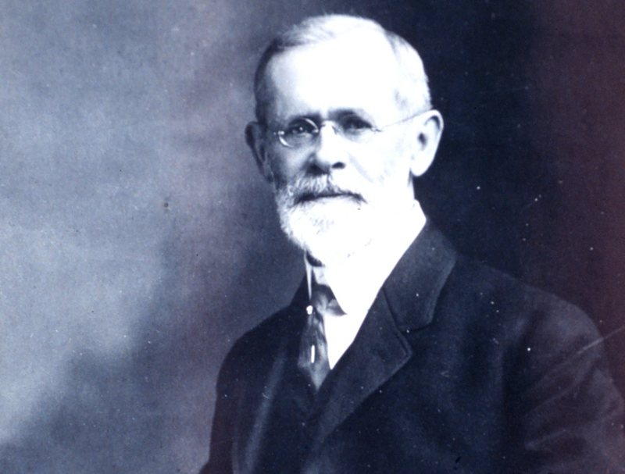Cleveland Abbe, father of the National Weather Service. NOAA/Public Domain
Abbe began his professional career as an astronomer, becoming director of the Cincinnati Observatory in 1868. But he soon became better known for his daily weather forecasts, the first such private predictions in the nation, which he would create based on climate information telegraphed in from outside observation stations. As he provided them to Cincinnati newspapers and other subscribers, they earned him the terrific nickname “Old Probabilities,” or “Old Probs.”
When the cash-strapped Cincinnati Observatory could not afford to maintain Abbe’s meteorological soothsaying, he moved his operation to Washington, under the auspices of the brand new United States Weather Bureau, of which he was made the first chief meteorologist. The bureau was part of the U.S. Army Signal Corps, which was the official body in charge of monitoring the country’s weather. Under this new meteorological body, Abbe gave his first official weather report in 1871, and quickly became the leading meteorologist in the country.

Enjoying This Story?
Get our latest, delivered straight to your inbox by subscribing to our newsletter.
So when the 1878 eclipse appeared on the horizon, excited astronomers turned to the Weather Bureau to locate the ideal place to witness the event, where weather conditions would be least likely to block their observations. Using historical weather data about the regions in the path of the coming eclipse, Abbe had the Signal Corps send out a circular that outlined some possible viewing sites. But as Baron describes him in his book, Abbe was still a “frustrated astronomer,” and he didn’t want to miss such an amazing celestial sight. Neither did his boss, General Albert Myer, who had witnessed an eclipse in Virginia in 1869.
Myer had viewed that earlier eclipse from a height of around 5,000 feet, and so decided he wanted to witness the 1878 eclipse from somewhere even higher. He chose Colorado’s Pike’s Peak, an ultra-prominence with a summit at over 14,000 feet above sea level, which not only sat right in the middle of the eclipse’s path, but already had a hard-scrabble meteorological station on top. When Abbe asked if he could go West to view the eclipse, Myer agreed.
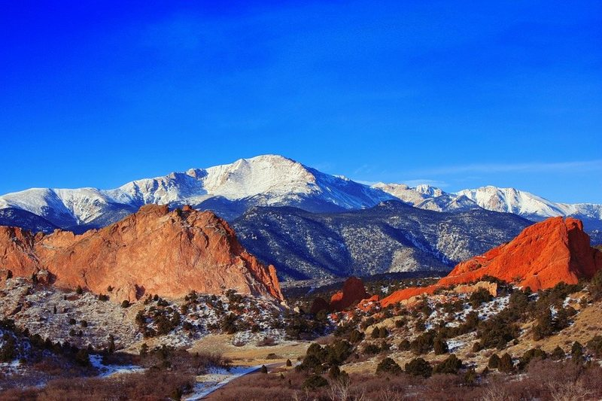Pike’s Peak today. RescueWarrior/Public Domain
“The scientists who got up there about a week in advance had just a hell of a time,” says Baron. Abbe got to Colorado Springs, at the base of the peak, on July 20, and was joined by fellow astronomer Samuel Pierpont Langley, plus Langley’s brother, and over a thousand pounds of equipment. The men of the Signal Corps were reportedly nonplussed by all of the surprise science work, but the crew made their way some 18 miles up the mountain to the observation station with the help of some burros.
Over the next week or so, Abbe and his colleagues were battered with wind, cold, and extreme weather as they tried to observe the skies in preparation for the eclipse. But that wasn’t the worst of it. “They were battling snowstorms in July that threatened to rust out their telescopes. They also suffered significant altitude sickness,” says Baron. Due to the extreme difference in air pressure and lack of oxygen at such a high altitude, the astronomers experienced headaches, dizziness, and disorientation. Many people can adjust to altitude sickness, but that was not the case for Cleveland Abbe.
The day before the eclipse, Abbe woke to pain so extreme he could not stand. The Langleys tried to convince Abbe to go down the mountain, but he refused, holing up in his tent, insisting that he could recover. Later that evening, General Myers finally made his way to the peak, where he ordered Abbe taken off the peak on a stretcher.
And it’s a good thing he did. “I ran [the story] by an expert in altitude medicine here in Colorado, and he agreed, it’s pretty clear that Cleveland Abbe had high altitude cerebral edema,” says Baron. “His brain was swelling and pressing on the inside of his skull. It’s the sort of thing where, had he spent another night up on the top of Pike’s Peak, he could very well have died.”
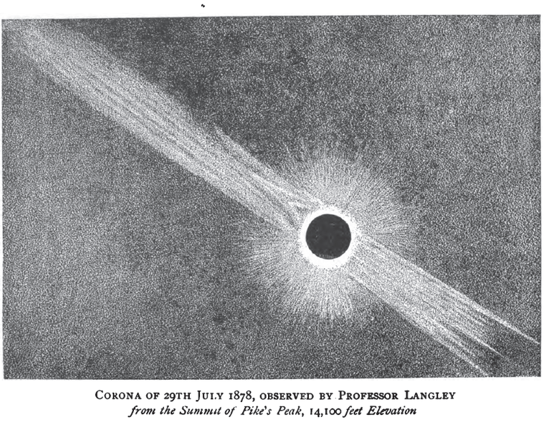An illustration of the eclipse as seen from Pike’s Peak. FSV/Public Domain
Abbe was carried down the mountain to a lodge that sat just below the tree line. A doctor arrived at the lodge and forbade Abbe from returning to the peak for the eclipse, but all was not lost for the pioneering weatherman. The next day, the skies over the mountain had miraculously cleared, and Abbe was able to convince his caretakers to carry him out and lay him on a slope where he could witness the totality with his own eyes. There, presented on the slope like a sacrifice to celestial mechanics, Abbe was able to see the moon pass in front of the sun, shooting vivid daggers of light off the ring of the corona.
Up at the summit, Myer and the Langleys got their own show. “First of all, they got to see the eclipse itself with amazing clarity, because there was less atmosphere to look through,” says Baron. “The outer atmosphere was just dazzling. But from that altitude, not only were they able to look up and see the eclipse, they were able to look out and look down, and actually see the moon’s shadow coming toward them.”
Abbe, Myer, and the Langleys all made it off the mountain, each going on to notable careers in their fields. Abbe returned to the Weather Bureau and worked to keep it at the forefront of meteorological advances during his tenure, before returning to academia in his later years.
The National Weather Bureau continued to evolve after Abbe’s passing in 1916, eventually becoming the National Weather Service that sends us texts about flash floods and studies our shifting climate today. But it could all have been sidelined by the Colorado eclipse.

Eclipse Madness
Presented by Elysian Brewing

http://www.naturalhistorymag.com/features/203184/the-agony-of-old-probabilities

The Agony of 'Old Probabilities'

How a solar eclipse imperiled the life of America’s first weatherman.
By David Baron
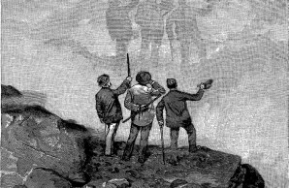
The scientists on Pikes Peak, during a break in eclipse preparations, marvel at their shadows on passing clouds.
Samuel P. Langley
Excerpted from David Baron’s forthcoming book American Eclipse: A Nation’s Epic Race to Catch the Shadow of the Moon and Win the Glory of the World (Liveright).
On July 28, 1878, America’s preeminent scientists assembled along the nation’s western frontier, ready for the total solar eclipse that would occur the following day. These intrepid men—and a handful of women—had trekked to Colorado and Wyoming in an era of Indian wars and train robberies to stand in the fleeting shadow of the Moon. They planned, during three precious minutes of midday darkness, to aim their telescopes and spectroscopes skyward in an effort to solve mysteries of the Sun and Solar System, and they hoped to make discoveries that would elevate their young country to an honored place on the global stage. But on this day before the eclipse, the scientists confronted a serious cause for worry: the weather.
Cumulus clouds “hovered over our fair city like birds of ill omen,” wrote an observer in Denver, “reducing to zero the hopes of astronomers, rousing the ire of many of our citizens and exciting the anxieties of all.” A run of storms in recent days boded ill for the eclipse because even a single cloud at the crucial moment could obscure the view and render the entire enterprise worthless. The unsettled weather rattled Thomas Edison, who was in Wyoming, where he planned to use his latest invention—an infrared detector called a tasimeter—to study the eclipsed Sun. The rain and hailstorms hampered the preparations of Maria Mitchell, the acclaimed Vassar professor, who was in Denver with an all-female astronomical party that she hoped would serve as a public demonstration of women’s abilities in science. The storms threatened to wash away a group of Princeton scholars encamped nearby along Cherry Creek. But of all the scientists bemoaning the inclement weather on that day before the great eclipse, the one who agonized the most—whose life was actually endangered by the atmosphere—was a pioneering meteorologist named Cleveland Abbe, the very man who had predicted clear skies.
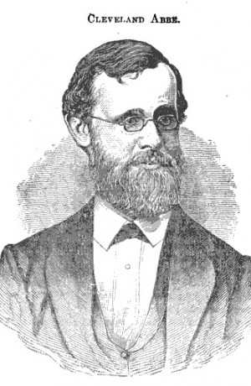
Cleveland Abbe, an astronomer and meteorologist, pioneered weather forecasting in the United States.
Nelson Sizer
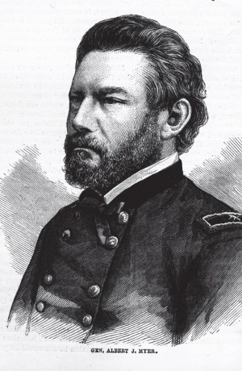
General Albert J. Myer hired Abbe when the U.S. Army Signal Corps launched the nation’s first weather bureau.
Frank Leslie’s Popular Monthly
The field of meteorology was admittedly immature and imperfect in 1878, but scientists had begun to understand how weather systems formed and moved, and the telegraph made real-time storm warnings possible. The head of the Smithsonian, Joseph Henry, had taken early steps in this direction in the 1850s, when he arranged for an assemblage of telegraph stations each morning to wire local weather conditions to Washington, where the information was posted at the museum (using colored cards on a large map) and published in the newspaper. The continually updated chart gave a general sense of storm systems moving across the country, but the Smithsonian did not issue formal forecasts. The federal government took on that responsibility a decade later, when a nascent weather service rose from the ashes of the Civil War.
During the war, Union commanders gathered information on Confederate troop movements with the help of a specially trained team—the Army Signal Corps—whose men climbed high hills and church steeples to scan the terrain and send back coded messages using flags, torches, and telegraphs. When the war ended, such skills were no longer in demand, but the Signal Corps’ leader, General Albert J. Myer, was an astute political operator. With his team’s budget slashed and its very existence threatened, he sought a new peacetime role. He found it in the late 1860s, when a spate of shipping disasters prompted Congress to call for the establishment of a federal storm-warning system. Myer argued that his corps possessed just the skills required: it could gather meteorological data at military posts across the country and then telegraph those statistics back to a central clearinghouse, “giving the presence, the course, and the extent of storms . . . as it would, in time of war, those of an enemy.” His lobbying succeeded. On February 9, 1870, President Ulysses S. Grant signed legislation creating America’s first national weather service. It would be operated by the Army Signal Corps.
General Myer had secured a fresh mandate and a vastly increased budget. What he lacked was a meteorologist.
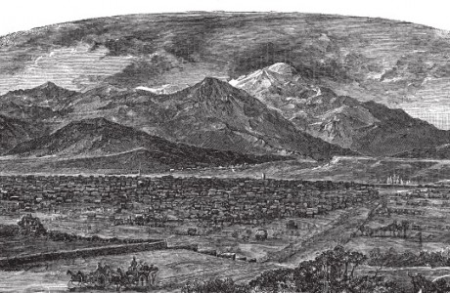
Pikes Peak and the city of Colorado Springs circa 1880.
Frank Fossett
Cleveland Abbe had not started his career in meteorology. His first love was astronomy, an odd passion for a severely nearsighted boy. After college and graduate school, he sought a permanent, paying job in the field, a quest that proved a long and protracted struggle. Finally, in 1868, he landed what appeared to be—on paper, at least—the ideal position: director of the storied Cincinnati Observatory, whose cornerstone had been laid in 1843 by an elderly John Quincy Adams. By the time Abbe arrived, however, the building was all but abandoned, its windows broken and its roof leaking. Out on the portico, one of the Greek columns was tipping over.
Abbe began repairs to the edifice, but he could not fix a bigger problem, the area’s worsening air pollution. Cincinnati—dubbed Porkopolis—was a booming city of meatpackers and brewers, and thick smoke often blanketed the sky. Since atmospheric conditions dictated how much one might see through a telescope, Abbe grew interested in meteorology, and he devised a plan to track the weather in Southwest Ohio. With the help of observers who telegraphed data from a broad geographic region, Abbe drew up daily forecasts—he called them probabilities—and, beginning in September 1869, he offered the service to area newspapers and private subscribers. For his efforts, this fledgling weatherman, though thirty years old, earned a fondly geriatric nickname: “Old Probabilities.”
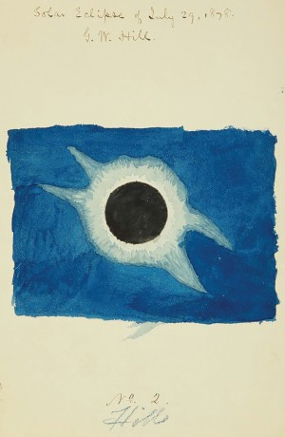
Watercolor of the total solar eclipse of 1878 by the mathematician and astronomer George W. Hill, who witnessed the rare event in Denver
Courtesy of National Archives
Cleveland Abbe had created something historic—the first regular weather forecasting service in the U.S.—but within a year the chronically cash-strapped Cincinnati Observatory was forced to abandon the venture, and Abbe too was soon dispatched, placed on unpaid leave. General Myer, just then seeking to create a weather service on a national level, offered Abbe a job as his chief meteorologist.
At last finding stable employment, Abbe moved to Washington. Recently married, he soon fathered a son, then two more. From his respectable salary he bought a sizable townhouse on I Street. His office was a short walk away, on G Street, where the Army Signal Service (as the Signal Corps had now come to be known) occupied a three-story brick building topped by weather vanes, rain gauges, wind meters, and other “toys which excite the envy of all the neighboring boys,” as one observer put it. A tangle of telegraph wires led inside, funneling in weather reports taken simultaneously at meteorological stations across the U.S. The reports arrived thrice daily, setting off a frenzy of work among a half dozen clerks. Standing at desks, they mapped precipitation, clouds, and wind velocity; drew isobars and isotherms to reveal patterns of air pressure and temperature; and then Abbe or one of the forecasters he trained would deduce how the weather was likely to change over the next day or two. Within an average of one hour and forty minutes, the latest forecast was ready—telegraphed to the press for publication nationwide.
Cleveland Abbe’s new job earned him a comfortable life and the respect of the scientific community, but he bristled under the office rules. He was a civilian of academic bent stuck in a military hierarchy. Whereas Abbe was gentle and bookish (his favorite pastimes were long walks and croquet), General Myer was rigid and domineering. While Abbe argued that the Signal Service must do more than just churn out forecasts—it should conduct basic research to advance the field of meteorology—Myer evinced little interest in theoretical studies. And there was another matter that, for Abbe, must have chafed. His superior had usurped his nickname. The newspapers had taken to calling General Myer “Old Probabilities.”
One summer evening in 1874, General Myer stopped by Abbe’s home. When a servant informed the visitor that the man of the house had already gone to bed, the general laughed—“What, so early?”—and left. The next day, Abbe recounted the incident in a letter to his wife, who was away on a seaside vacation. “Somehow I always feel better when I thus miss seeing him,” Abbe admitted. “I suppose I am foolish & wicked but I can’t help pining for freedom & a telescope.”
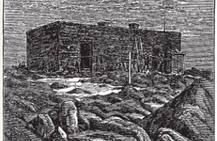
The U.S. Army signal station on Pikes Peak. At an elevation of over 14,000 feet, it was the highest-altitude weather post in the world.
Frank Fossett
In early 1878, as astronomers began planning for the total eclipse that would cross the American West (painting a trail of darkness from Montana Territory to Texas), they called on the Signal Service for an obvious reason—to help identify viewing posts with good odds of clear skies. Cleveland Abbe took on the job, which required the compilation and analysis of historical data from weather stations that fell within or near the computed path of the moon’s shadow. According to Abbe’s math, southern Wyoming should enjoy a 79 percent chance of favorable conditions at the time of the eclipse. At Denver, the numbers were less optimistic, but he still calculated better than even odds of a clear view, at 60 percent. The Signal Service issued these figures, and many others, in a circular that it distributed to the government and the press.
But Abbe, the frustrated astronomer, aspired to do more than provide advice; he hoped to observe the eclipse himself. General Myer was interested in the eclipse, too— after all, it was only appropriate for the nation’s meteorological bureau to use the event to study the Sun, since the Sun drives the weather on Earth—and he immediately focused on a prominent geographic feature that sat in the middle of the eclipse path in Colorado. This was Pikes Peak, which rose more than fourteen thousand feet above sea level and held on its top a Signal Service meteorological post, the highest-altitude weather station on the planet. Manned year-round and connected to the outside world by a seventeen-mile telegraph line, the post imposed harsh duty on its small staff of resident soldiers, who endured electrical storms, hurricane-force winds, frostbite, and the nausea, headaches, and dizziness brought on by the thin atmosphere. Myer hoped to go to Pikes Peak himself, but even if he could not, he wanted another qualified observer on the summit. On this rare occasion, General Myer and his chief scientist saw eye to eye. They agreed: Cleveland Abbe should go to Colorado. He should climb the mountain to observe the hidden Sun.
On Friday, July 20, 1878, Cleveland Abbe arrived in Colorado Springs, near the base of Pikes Peak, and checked into the Crawford House. The hotel, at two dollars a night, did not especially impress him, but he was pleasantly surprised by the city—its irrigated yards, its energetic spirit. As for the weather, it could hardly have been better. “This morning the sky is everywhere as clear as a bell and the blue is such a deep fine solid blue that it’s inspiring to an astronomer to look at it,” he wrote to his wife on Saturday. Less fine were his preparations to ascend the mountain. “There’s a good deal of confusion,” he acknowledged.
Abbe was not to be the sole astronomer on the summit. Samuel Pierpont Langley, director of Pennsylvania’s Allegheny Observatory, knew Abbe from the days when they both toiled as novice directors at poorly funded astronomical institutions along the Ohio River. The two men arranged to join forces on Pikes Peak. “It’s first-rate;—your going;—we’ll have a time—hurroo!” Langley wrote to Abbe the month before the eclipse, then received a kind offer of logistical help from the Signal Service. “[General Myer] takes pleasure in offering you the hospitalities of the Signal Station at the summit for such time as you may need,” read the letter from Washington dated June 13.
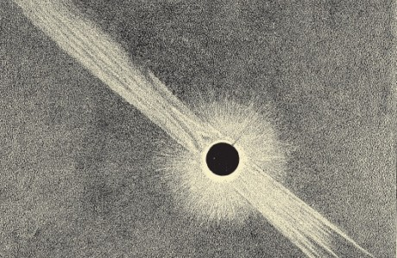
The Sun’s outer atmosphere—its corona—as seen from Pikes Peak during the total eclipse of 1878 and sketched by astrophysicist Samuel P. Langley.
Samuel P. Langley
Several weeks later, however, when Langley reached Colorado, he found the local Signal Service officers unprepared for his arrival. He had brought along an assistant— his brother—but was told “there was no room for [either of] us in the Signal Service station on the summit.” He had also brought twelve hundred pounds of equipment, and—as he wrote in frustration—“The distance to the Peak was, as we now learned, 18 miles by a foot-path. . . . No wheeled conveyance was possible.” This was not the situation he had anticipated, but it was too late to relocate his observation post, so an arrangement was made to hire burros. The Langley brothers repacked their equipment into smaller boxes, which were then suspended between pairs of donkeys and ferried to the peak by drivers who hurled rocks and profanities at the animals to keep them plodding up the narrow trail. The rugged path crossed a raging mountain stream, angled up a deep gorge, passed waterfalls and crags and snowfields, and finally emerged above the timberline to reveal vast meadows of alpine wildflowers. At the summit, the Langleys—soon joined by Cleveland Abbe—found the weather station to be a small stone hut, overcrowded and half in ruins. Surrounding it was a broad expanse of jagged boulders. Abbe had brought tents, but there seemed to be no suitable spot to pitch them, so the men constructed platforms out of firewood. They covered the wood with damp hay, then tied the canvas to the rocks with wire. The ensuing days brought occasional moments of pleasure. The three scientists gazed down and east across the plains, which stretched like an ocean to a shoreless horizon. They looked west over forested valleys, shining lakes, and snowcapped peaks. They marveled at the play of light and shadow on the clouds that rolled by. But the remainder of the time—almost all of it, in fact—was torment. The weather, as Abbe so delicately phrased it, “was more than usually unpropitious.” He telegraphed Washington with updates each evening at nine. On Wednesday, he wired: “Cold rain all this afternoon.” On Thursday: “Rather disagreeable weather.” Friday: “Occasional glimpse of the sun, but mostly snow, fog, and clouds.” And Saturday, just two days before the eclipse: “Two snow storms with gales endangering tents and instruments. No satisfactory glimpse of sun today. Very little progress in preparing for Monday.”
The telegrams did not adequately convey the misery. At night, under damp blankets, the men struggled to sleep while the wind roared and shoved—intending, it seemed, to blow them, tents and all, off the mountain. In the day, during brief intervals of sunshine, the astronomers strove to set up their telescopes, but as soon as they unwrapped the equipment from its protective canvas, the clouds again unleashed rain or hail. (To prevent his telescope from rusting, Samuel Langley covered its steel parts with lard.) A reporter who scaled the mountain to interview the scientists declared them “the bluest party of astronomers that could have been found in the great state of Colorado. They had almost abandoned the hope of a favorable view of the eclipse, and were in a state of profound and unanimous disgust.”
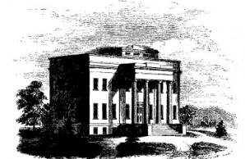
The old Cincinnati Observatory, its cornerstone laid in 1843 by John Quincy Adams.
Harper’s New Monthly Magazine, 1874
The worst of their suffering was not emotional, but physical. In the thin atmosphere, their hearts raced, and the slightest exertion left them gasping for air. “I lay awake the second night, drawing long breaths, in the vain attempt to breathe once satisfactorily,” Samuel Langley wrote, “and remember thinking occasionally of a mouse I once saw experimented on, under the bell of an air pump, with a sympathy, born of new experience.” The men were being starved of oxygen. They developed acute mountain sickness. “[W]e felt constant and severe headache, and nearly every symptom which attends sea-sickness,” Langley recalled.
After a few days, the Langley brothers gradually began to acclimate, but not so Cleveland Abbe. His symptoms steadily worsened until, on Sunday morning—the day before the eclipse—he awoke in his tent to paroxysms of pain in his head and upper back, and he was unable to rise. Abbe’s inability to stand suggests that he had developed a dangerous condition known today as high-altitude cerebral edema. His brain was swelling, squeezing against the skull. The resulting pressure can rapidly cause confusion, hallucinations, coma, and—especially if one spends another night at high altitude—death.
The underlying physiology of Abbe’s condition was not understood in 1878, but John W. Langley had been trained as a physician, and he could tell that Abbe’s infirmity was potentially lethal. Langley implored Abbe to evacuate to a lower altitude, but Abbe refused, adamant that he should remain on the peak for the eclipse. His stubbornness was understandable given that he had come so far, but he likely too was suffering from impaired judgment, a common symptom of high-altitude cerebral edema. So Abbe remained in his tent, under the illusion that with rest he would recuperate.
Meanwhile, some eight thousand feet below, beginning his own ascent of the mountain, was the man Abbe preferred to avoid when possible. General Myer, “otherwise known as ‘Old Probabilities,’” as a Denver newspaper wrote, had arrived in Colorado the previous day. At 5:00 p.m., the general emerged on the summit and found his chief meteorologist an invalid. Whereas the Langleys could only try to persuade Abbe to evacuate, Myer had the authority to issue a command, which he did. Abbe was thus loaded on a stretcher. By 6:30, four men were carrying him like pallbearers down the rocky, zigzag trail.
Flat on his back on the litter, Cleveland Abbe faced skyward through woozy consciousness. As the Sun set for its final time before the great eclipse, he watched the heavens darken. Although in his hasty retreat from the summit he had forgotten his strong spectacles for stargazing, he could still, with his weaker prescription, pick out the constellations: Cygnus, Lyra, Aquila, Cassiopeia. The Milky Way, a vivid band across the firmament, shone auspiciously-evidence, at last, that the skies had cleared.--DB

http://www.weather.gov/cae/newberryeclipse.html
Columbia, SC
Weather Forecast Office

2017 Total Solar Eclipse and the Re-creation of the 1900 Solar Eclipse Expedition
Weather.gov > Columbia, SC > 2017 Total Solar Eclipse and the Re-creation of the 1900 Solar Eclipse Expedition
2017 NWS Eclipse Expedition to Newberry, SC
The U.S. Weather Bureau sent a team of meteorologist to study the total solar eclipse of May 28th, 1900. There was much interest at the turn of the century among scientists about the effects of the moon’s shadow up on the earth’s atmosphere. Because of the technology of the day, this was the only time scientists could actually look directly at the sun to make observations. The U.S. Weather Bureau expedition consisted of 11 people traveling to the town of Newberry, SC for the eclipse.
Due to the nature of such an extraordinary effort by the U.S. Weather Bureau to document and observe the eclipse in 1900, NWS WFO Columbia decided to re-create much of the event for the August 21st, 2017 total eclipse.

Historical Perspective
The 1900 Expedition consisted of:
Cleveland Abbe (U.S. Weather Bureau) – Father of weather forecasting in America, former director of Cincinnati Observatory, veteran of 1869/1878/1889 eclipse expeditions.
Frank Bigelow (U.S. Weather Bureau) (accompanied by his wife Mary) – Designed large format eclipse camera for Newberry expedition. Compiled weather data, from a 3 year study (1897-1899) for astronomers in advance of the eclipse. Veteran of 1889 eclipse expedition to West Africa. Published, Eclipse Meteorology and Allied Problems, in 1902 through the U.S. Department of Agriculture – Weather Bureau

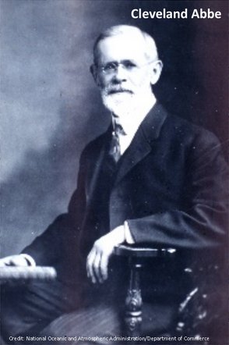 | 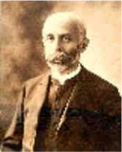
Cleveland Abbe | Frank Bigelow

Roberdeau Buchanan (Nautical Almanac Office) (accompanied by his wife Lyla) – Longtime eclipse calculations expert at the Nautical Almanac Office. Published a book, The Mathematical Theory of Eclipses, in 1905.
Walter Scott Harshman (U.S. Naval Observatory) (accompanied by his wife Francis) – Future director of the Navy’s Nautical Almanac Office.
James Page (U.S. Hydrographic Office) – Served as editor for the pilot charts issued by the Hydrographic Office to aid mariners at sea. Participated in the International Boundary Commission’s expedition to survey the U.S.-Mexican border between the Rio Grande and the Pacific Ocean.
Miss Eliza Wilkes – from Washington D.C.
Miss Jane Wilkes – from Washington D.C.
Miss Lindsay – Washington D.C.
W.K. Sligh (Newberry College Mathematics Professor) – joined the part at the site.
J.Z. Salter – group photographer
The expedition chose to set up on the grounds of the home of Dr. W.G. Houseal at 722 Caldwell Street in Newberry. The path of the total eclipse crossed from New Orleans to Norfolk, with Newberry near the center-line of totality. The time of totality was approximately 1 ½ minutes.

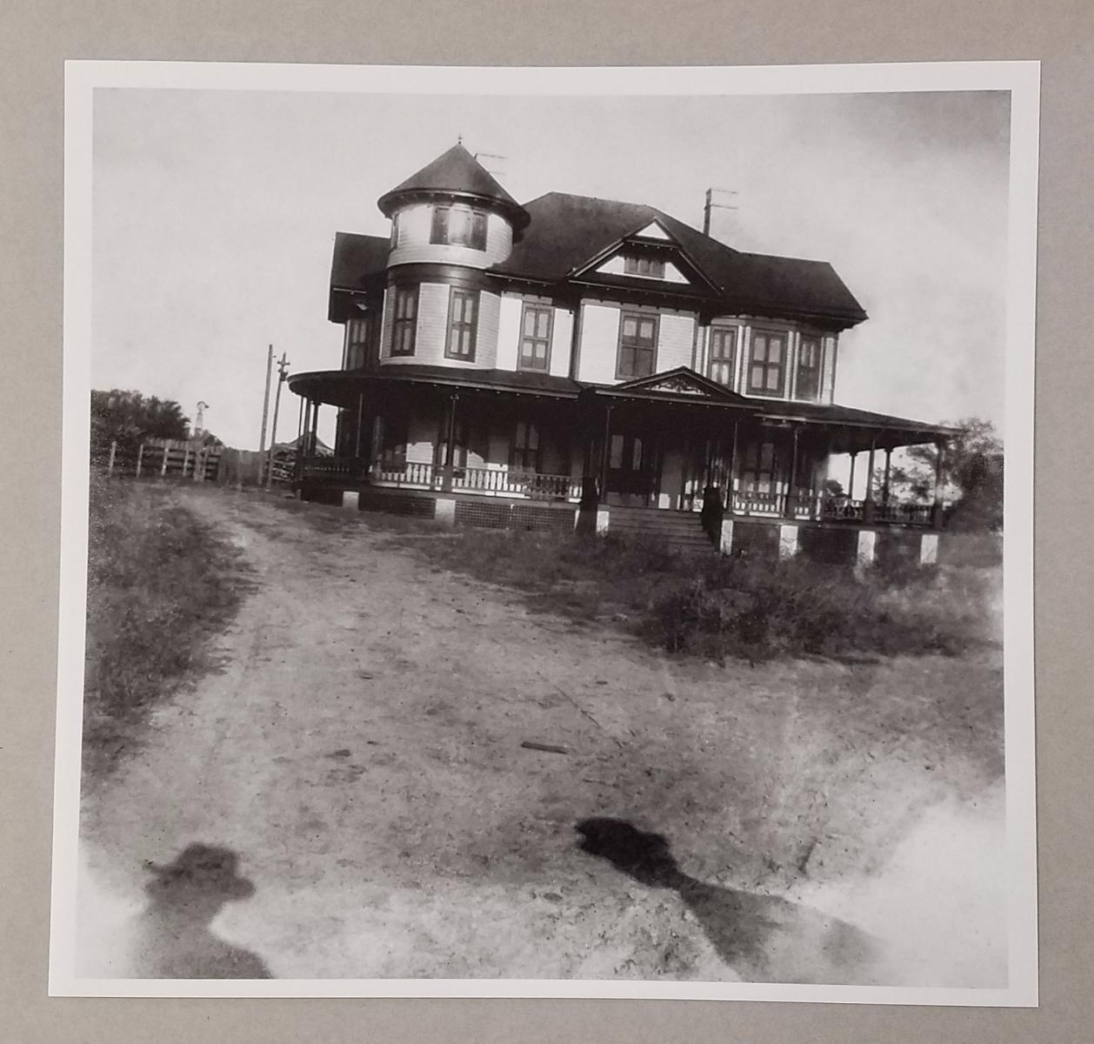 | 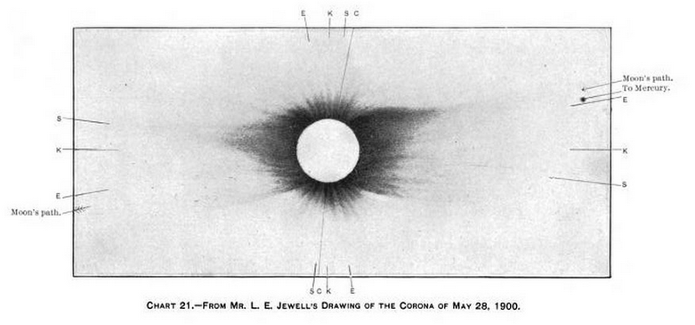
House of Dr. W.G. Housel- Photo courtesy of Turner Photography and Restoration | Drawing of the 1900 Corona
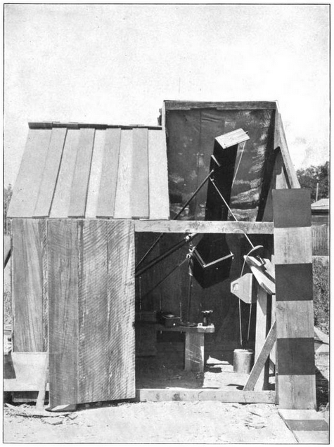 | 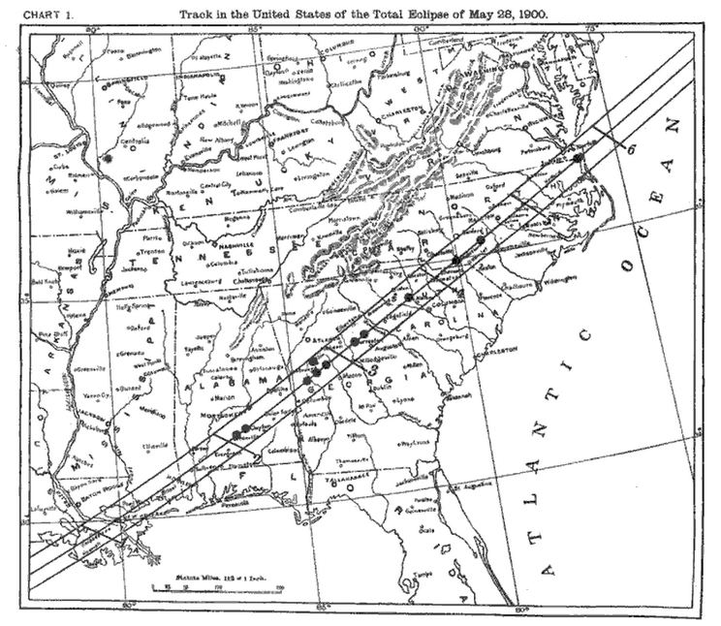
Telescope Used in 1900 Expedition | Total Solar Eclipse Path in 1900

2017 Eclipse Re-creation
The National Weather Service partnered with Tom English, Director of the Cline Observatory at Guilford Technical Community College in Jamestown, NC near Greensboro, NC and Sam Zaidy, director of the Newberry County Library. Warren Page, the current owner of Dr. Houseal’s home, gave us permission to conduct our observations at the original 1900 Expedition site. Leonard Vaughan, Service Hydrologist, and Hunter Coleman, Lead Forecaster at WFO Columbia conducted the observations. Leonard even dressed the part for the re-creation wearing clothing from around 1900. Observations were taken every 5 minutes through the event from 1pm through 4:15pm. 1 minute observations were taken during the peak of the event from 2:20pm through 3:20pm.

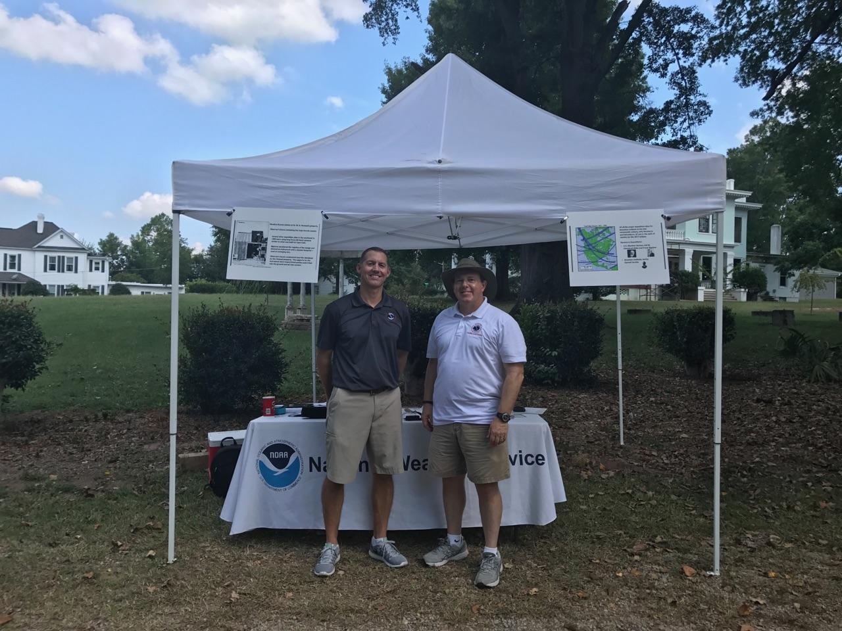
NWS Columbia Meteorologist, Hunter Coleman and Service Hydrologist, Leonard Vaughan

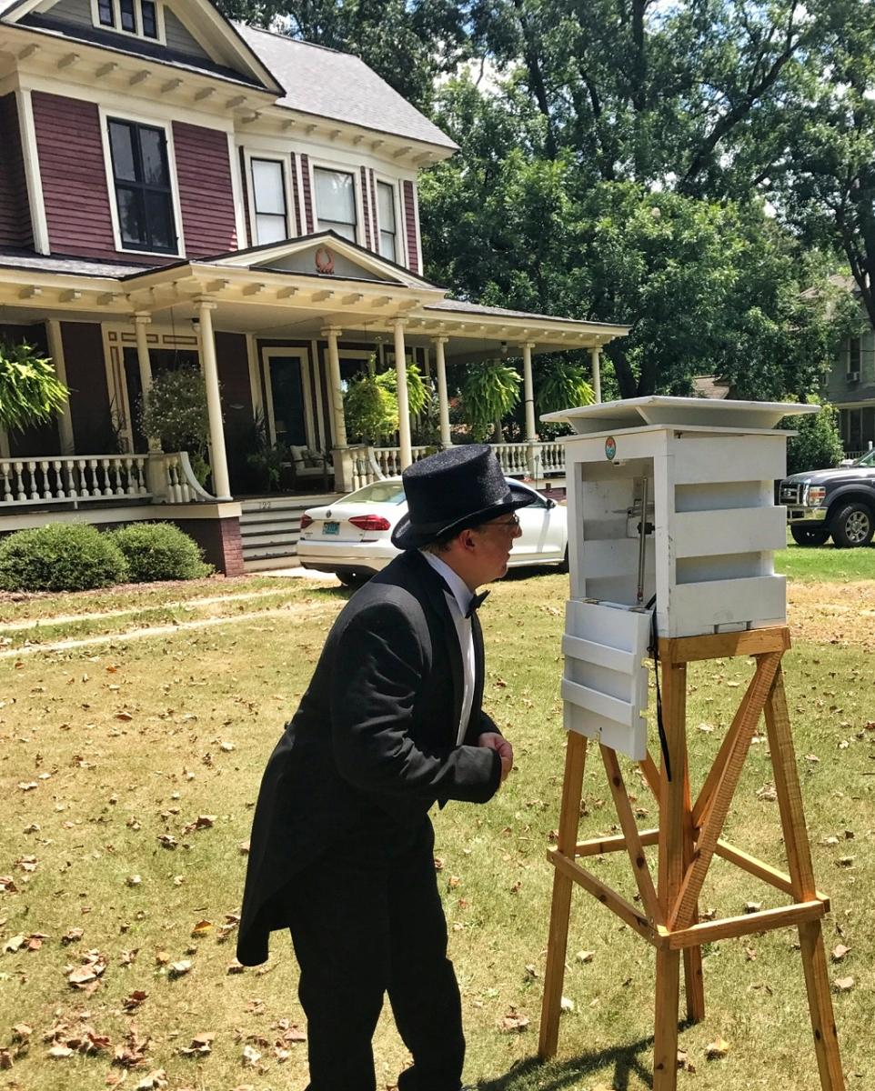
NWS Columbia Service Hydrologist Leonard Vaughan taking observations

The South Carolina State Climatology Office provided a cotton region shelter to house our thermometers. Observations of temperature where taken using alcohol thermometers and a portable handheld Kestral Wind and Weather Meter. The thermometers and Kestral were placed inside the shelter. Sky conditions, changes in temperature and animal behavior were annotated through the event.

Eclipse Details
Partial Eclipse Began – 1:11:33 PM
Totality Begins – 2:40:14 PM
Maximum Totality – 2:41:33 PM
Totality Ends – 2:42:48 PM
Partial Eclipse Ends – 4:05:03 PM
Duration of Totality – 2 minutes and 31.8 seconds
Location 34.271 N/81.617 W

Eclipse Observations
- Temperatures warmed to 95 degrees prior to the eclipse onset
- A 3 degree drop in temperature was observed around 1:50-1:55pm, likely associated with increasing clouds and possible outflow from a nearby shower
- A 4 degree drop in temperature was noted from 2:20-2:40 (just before totality) associated with the loss of solar radiation due to the eclipse
- Around 2:31 pm Cicadas and other insects began making audible noise which became louder through totality
- A flashlight needed to be used to make temperature observations starting at 2:36 pm
- Several flocks of Purple Martins and Swallows began to fly in a confused manner around totality
- Flashlight was no longer need to make temperature observations after 2:48pm
- 84 degrees was the minimum temperature observed which occurred around 5 minutes after totality
- Noticeable reduction in cumulus clouds just after totality and remained mostly cloud free through the end of the observation period

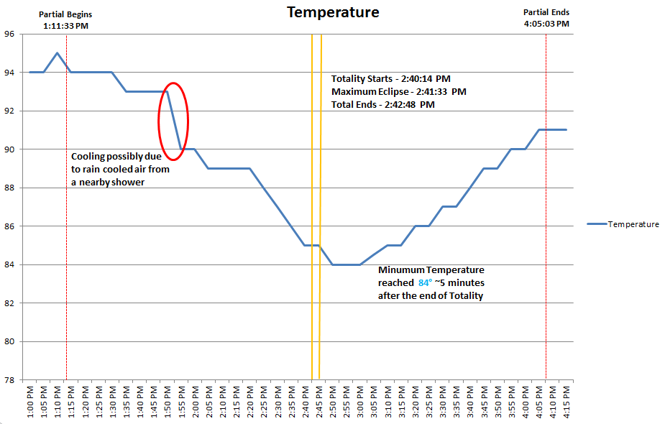
Temperature graph of the observations taken in Newberry, SC

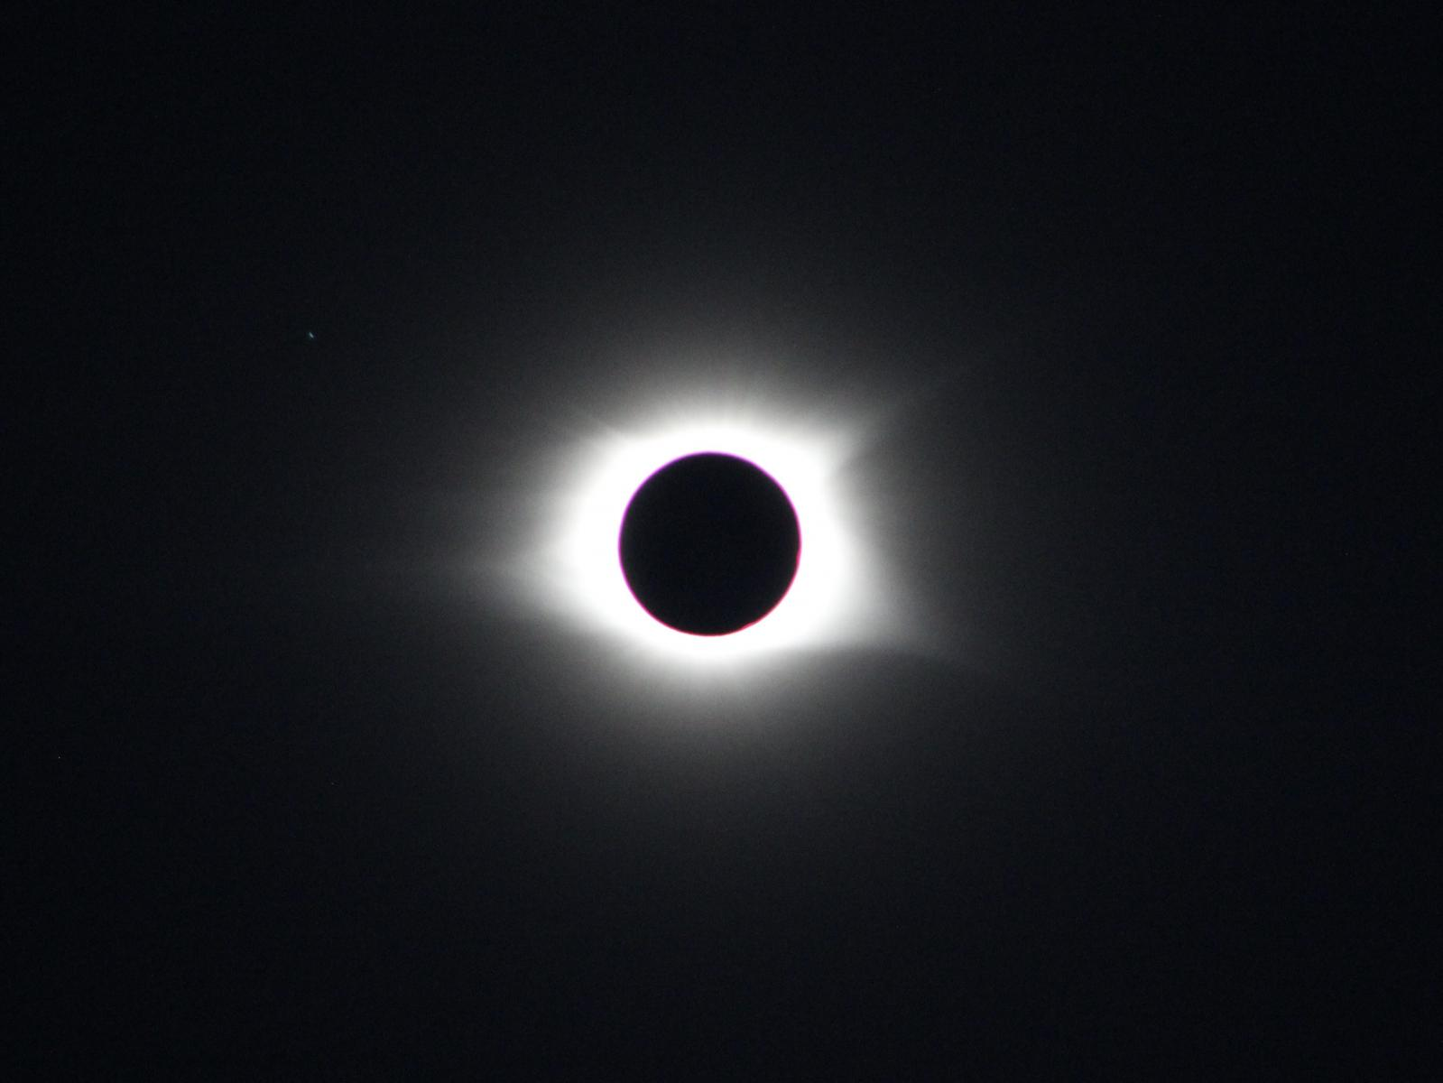
Photo of the 2017 Solar Eclipse at totality taken by NWS Columbia Meteorologist, Hunter Coleman

See also http://www.dnr.state.mn.us/climate/journal/170821_eclipse.html

Past Weather in the Twin Cities for the August 21, 2017 Eclipse
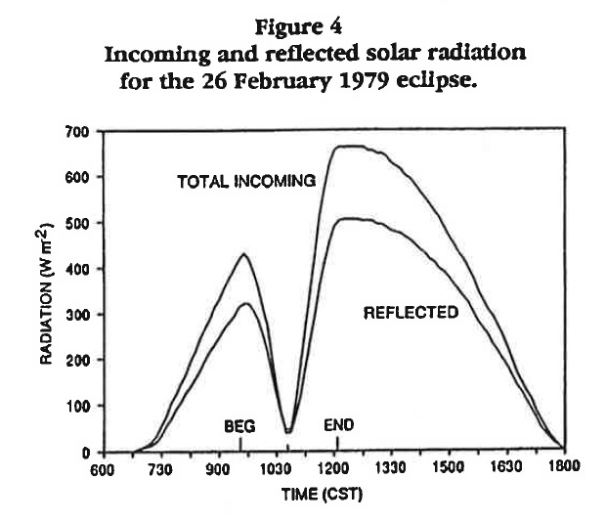
Solar radiation at the St. Paul Campus Climate Observatory: February 26, 1979.
Courtesy: Journal of the Minnesota Academy of Science, Fall 1994

What are the odds that viewers will be able to see the the partial eclipse of August 21, 2017 in the Twin Cities?
As the event draws near, follow the National Weather Service Forecast.
In the Twin Cities, 83% of the sun will be covered by the moon at 1:06pm CST August 21, 2017. Looking at recent 1 PM observations in the Twin Cities since the year 2000, skies were mostly sunny (3/8 cloud cover or less) seven of the past 17 years, partly sunny (3/8 to 5/8 cloud cover) five times, and cloudy (7/8 cloud cover or greater) five times. Temperatures have ranged from 65 degrees in 2004 to 84 degrees in 2013. It can occasionally be quite windy with a sustained wind of 17mph with gusts to 24 mph in 2008.
And what should we expect from the August 21st, 2017 eclipse? We should see a noticeable loss of daylight, even if it's cloudy, because up to 86% of the available sunlight will be blocked by the moon. Partial eclipses of the past have produced dusk-like sunlight levels, even during the middle of the day. The 2017 eclipse will occur at a time when temperatures normally would be climbing by a degree or two per hour, but we should expect temperatures to lose ground for an hour or so, possibly affecting our ability to reach what would have been the high temperature otherwise. Although we will not be in the "path of totality," observant Minnesotans will have no problem recognizing the partial eclipse.
The National Weather Service has more Eclipse Information.
Below is a list of sky conditions and weather at 1pm August 21 for past years in the Twin Cities.
Year location SKY/WX TMP DP RH WIND PRES
---------------------------------------------------------
2000 TWIN CITIES CLOUDY 67 60 78 SE10 30.10F
2001 TWIN CITIES MOSUNNY 79 64 60 S13 29.83F
2002 TWIN CITIES PTSUNNY 69 67 93 SE14 29.86F
2003 TWIN CITIES CLOUDY 77 61 57 NW15G22 29.96R
2004 TWIN CITIES MOSUNNY 65 34 31 S13 30.05F
2005 TWIN CITIES MOSUNNY 71 52 50 NW9 30.12F
2006 TWIN CITIES MOSUNNY 83 57 41 VRB3 30.11F
2007 TWIN CITIES CLOUDY 74 67 78 NE6 29.84F
2008 TWIN CITIES MOSUNNY 83 62 49 S17G24 29.94F
2009 TWIN CITIES PTSUNNY 68 54 60 NW13 29.87S
2010 TWIN CITIES CLOUDY 77 68 73 NE6 29.93R
2011 TWIN CITIES MOSUNNY 74 51 44 SW7 30.03S
2012 TWIN CITIES MOSUNNY 76 44 32 S8 30.07F
2013 TWIN CITIES PTSUNNY 84 72 67 SW8 29.90R
2014 TWIN CITIES PTSUNNY 82 71 69 SE8 29.76F
2015 TWIN CITIES CLOUDY 74 58 57 S12G18 29.86S
2016 TWIN CITIES PTSUNNY 71 48 43 NW8 29.99R

http://www.dnr.state.mn.us/climate/journal/170821_eclipse_results.html

The 2017 Eclipse in Review
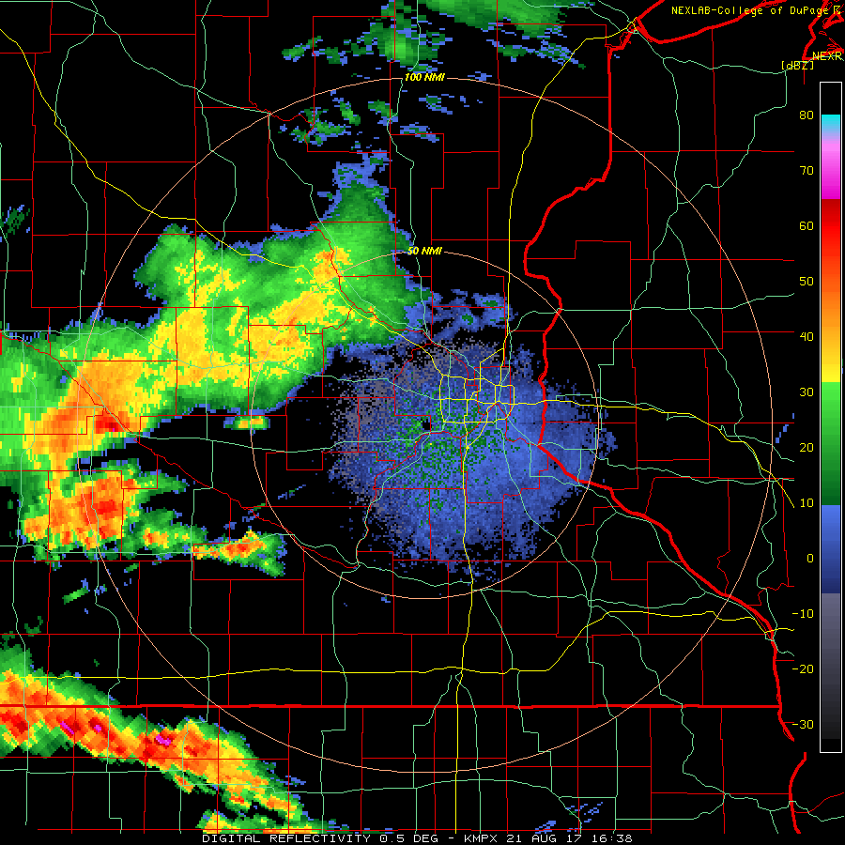
Radar loop showing precipitation advancing across southern MN on August 21, 2017. First half of loop was during the partial eclipse.
Loop courtesy of College of Dupage

The much anticipated 2017 solar eclipse occurred amid a mix of clouds, rain, heavy thunderstorms, and limited clearing in Minnesota.
Morning thunderstorms in southern and western Minnesota had placed a heavy overcast across much of of the state. At 11:45 AM CDT, as the eclipse was beginning, strong thunderstorms with intense rains were affecting the Minnesota River valley, and parts of far southwestern Minnesota along the Iowa border. Light to moderate precipitation was falling across the Willmar and St. Cloud areas. Cloud-filtered sunlight was visible across the Twin Cities area, and predominantly sunny conditions were noted across the southeastern 1/4 of the state.
The clouds and rain advanced eastward, and only far southeastern Minnesota was able to experience the eclipse without significant interference from cloudcover. Almost everywhere else, dense clouds and rain made for poor viewing conditions and certainly made it difficult to identify the effect of the eclipse, versus that of the overcast.
Despite the less-than-ideal visual conditions, the eclipse had a notable effect on Minnesota's weather. On a typical day, the sunlight passes directly to the earth, but any clouds present will filter some of that sunlight. During the eclipse, however, Minnesota had 70-90% of the direct sunlight blocked by the moon, before that light even reached the clouds, resulting in far less than usual mid-day heating at the surface. As a result, locations with cloudy and clear skies alike saw temperatures drop between noon and 2 PM. At Rochester, skies were clear through the majority of the eclipse, and temperatures fell by five degrees in just two hours.
Station | Noon Temp (F) | 2 PM Temp (F) | Change (F) | Sky conditions
Duluth | 67 | 64 | -3 | Clouds
International Falls | 70 | 66 | -4 | Scattered clouds
Rochester | 78 | 73 | -5 | Clear
Twin Cities | 79 | 77 | -2 | Clouds

Last modified: August 22, 2017
For more information contact: climate@umn.edu

